Lesson 6: Developing a Concept

through the Iterative Design Development Process in Interior Design

The process of Interior Design is much more than just selecting colours, furniture, and decor. At its core, interior design is about problem-solving, storytelling, and creating functional yet aesthetically pleasing spaces. To achieve this, designers use an iterative design development process, refining their concepts through a series of structured steps: research, analysis, planning, ideation, exploration, testing, presentation, review, and repetition. This article will guide you through each phase and explain how to develop a strong design concept effectively.



Fig 1.Pexels (nd), a man presenting at the meeitng

# What is a Concept?

A concept in interior design refers to the central idea or theme that drives the entire project. It serves as the foundation for design decisions, guiding the selection of materials, colors, furniture, and layout. A well-developed concept ensures coherence, functionality, and a meaningful connection between the space and its intended purpose or users.

# What is a Iteration?

Iteration is the process of refining and improving a design through repeated cycles of development. In interior design, iteration involves revising ideas, testing different solutions, and incorporating feedback to enhance the final outcome. This cyclical approach allows designers to explore multiple possibilities, resolve challenges, and create spaces that are both visually appealing and highly functional.

Let us look at the stages of Iteration, as they may be applied in the process of Concept Development, for an Interior Design project:

# Reserach

Every great interior design project begins with thorough research. This involves understanding the client's needs, lifestyle, and preferences. Designers should gather information about the intended space, including its dimensions, structural limitations, and environmental factors. Research can also include studying historical influences, cultural elements, and emerging design trends. Visiting similar spaces, collecting inspiration from books and online resources, and creating mood boards can help form a clear vision.



Fig 2. Pexels (nd) A person reading a script

# Analyse

Once research is collected, the next step is to analyze the information. This phase helps designers define the project’s goals, identify constraints, and prioritize functional requirements. A critical part of this step is understanding user behavior and ergonomics, ensuring that the space will be both practical and comfortable. SWOT (Strengths, Weaknesses, Opportunities, and Threats) analysis can also be applied to assess feasibility and optimize the design direction.

# Plan

Planning involves creating initial sketches, zoning spaces, and developing layout strategies. Designers must consider circulation, accessibility, lighting, and furniture placement to optimize usability. At this stage, bubble diagrams and spatial planning tools help visualize how different elements will interact within the space. Establishing a timeline and budget for the project also ensures that the concept remains realistic and achievable.

# Ideate

In this phase, creativity takes center stage. Ideation involves brainstorming different ideas, styles, and themes to find the best design solution. Sketching, digital modeling, and concept boards help refine ideas. Designers often explore various styles and routes to see which best suits the project's objectives. Inspiration from nature, art, and architecture can also influence the conceptual direction.



Fig 3. Pexels (nd) [Man Wearing Black and White Stripe Shirt Looking at](https://www.canva.com/photos/MADGxhpeGw4/) [White Printer Papers on the Wall](https://www.canva.com/photos/MADGxhpeGw4/)

# Explore

Exploration involves testing different materials, textures, and color palettes to see how they interact within the space. Designers experiment with various combinations of finishes, textiles, lighting, and furniture selections. This hands-on approach ensures that the chosen elements work harmoniously together. At this stage, scale models or digital renderings can help visualize the final look.

# Test

Prototyping and testing are essential to refining the design concept. Designers create sample boards, material swatches, or 3D renders to see how elements work together in real life. Mock- ups and test installations help identify potential issues before finalizing decisions. Feedback from clients and peers is crucial to refining the design and addressing any inconsistencies.

# Present

Once a refined concept is ready, designers must present their ideas to clients or stakeholders. Presentations often include mood boards, digital renders, floor plans, and sample materials.

Communicating the vision effectively is key to gaining approval and moving forward with the project.

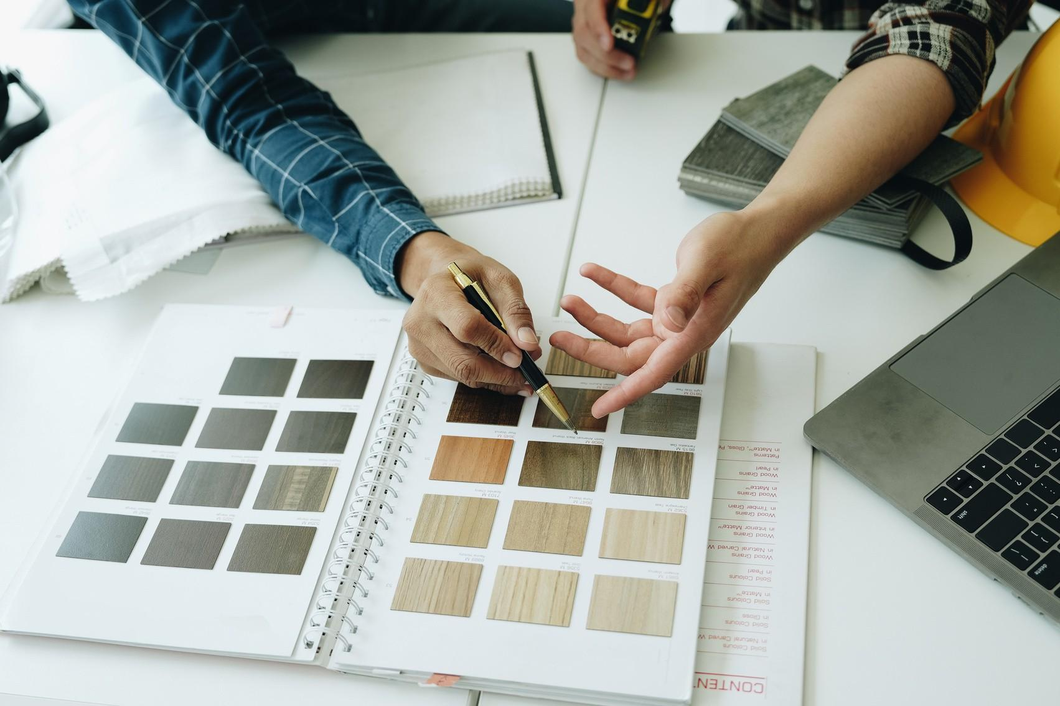

Fig 4. Getty Images (nd), [Engineers, designers and interior designers are finalizing the design of](https://www.canva.com/photos/MAFlnqt2zMA/) [interiors by discussing selecting materials and colors to design rooms to present to clients.](https://www.canva.com/photos/MAFlnqt2zMA/)

# Review

After presenting the concept, it’s time to review feedback and make necessary adjustments. Clients may request changes, and designers must evaluate how to incorporate these while maintaining the project’s integrity. Constructive critique is an essential part of the iterative design process, ensuring that the final outcome meets all requirements.

# Repeat

Iteration is key in interior design. The process of refining, testing, and reviewing continues until the perfect balance between functionality, aesthetics, and user experience is achieved. Each loop through the iterative process helps designers create well-thought-out, innovative spaces.

Developing a concept through the iterative design development process is essential in interior design. By following structured steps—research, analyse, plan, ideate, explore, test, present, review, and repeat—designers can refine their ideas, address challenges, and ultimately create inspiring spaces that fulfill both practical and aesthetic goals. Embracing this methodology ensures continuous improvement and successful design outcomes, making it a vital skill for any aspiring interior designer.